DS 522 Data Acquisition and Analytics
HOS03A-1 – Set Up Jupyter Notebook
07/15/2024 Developed by Catherine Ata
03/05/2025 Reviewed by Yogesh Goel
04/15/2025 Reviewed by Naveena Moddu
03/26/2026 Reviewed by Vishal Krishna Kumar

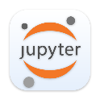


School of Technology & Computing (STC) @ City University of Seattle (CityU)

Take Note Before Starting
• The directory path shown in screenshots may be different from your directory.
• Not every step is explained in the tutorial. If you are not sure what to do:
1. Consult the resources listed below.
2. If you cannot solve the problem after a few tries, email your course TA for help.

Learning Outcomes
• Understand IPython environment.
• Learn how to install Jupyter extension on Visual Studio Code.
• Learn how to run programs in Jupyter notebook.

Resources
- McKinney. (2022). Python for Data Analysis (3rd edition).
- Tutorials Point. (2024). Jupyter. https://www.tutorialspoint.com/jupyter/ipython_introduction.htm

Getting Started
- Open VS code and within VS Code, open the DS522 course folder created earlier. On the menu tab, select File, then Open New Folder. Navigate to your work directory or GitHub repository that you have cloned.
For example: C:\Users\my_workspace\Desktop\DS522
OR C:\Users\my_workspace\Desktop\DS522\github_repository_name
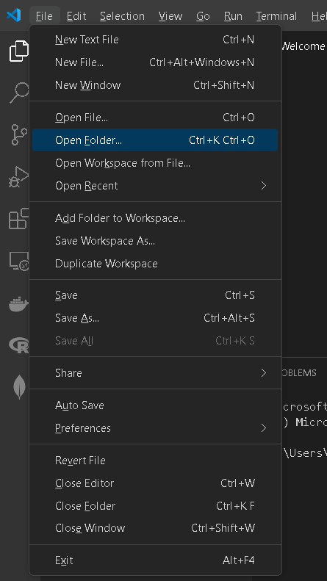
NOTE: If you have cloned a GitHub repository that is provided specifically for this course, navigate to that directory and skip steps 2 to 4. This will be the folder where you will be storing all your HOS03A work.
- Once in your work directory, go to the menu tab again, select Terminal, select New Terminal to open a Command Line Interface (CLI) like the Command Prompt or PowerShell for Windows OS.
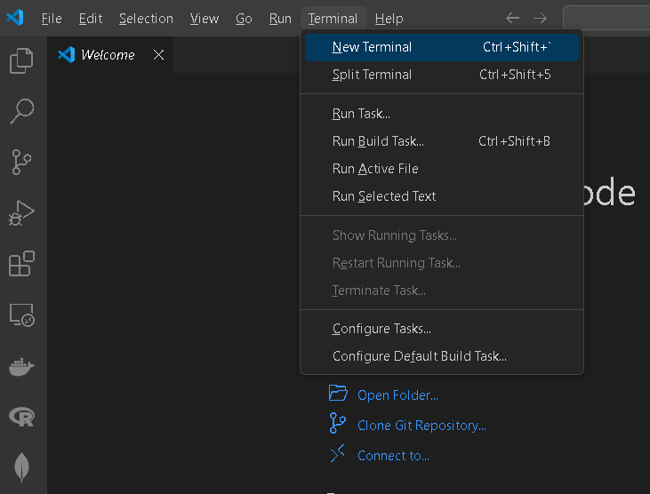

- Inside your “DS522” directory, create a new directory and name it “Module03”. Use the following command:
>mkdir Module03
- Move to the new directory. Use the following command:
>cd Module03
NOTE: This will be the folder where you will be storing all your HOS03A work.
Python and Jupyter Notebook

What is Project Jupyter?

Project Jupyter is a comprehensive software suite for interactive computing, that includes various packages such as Jupyter Notebook, QtConsole, nbviewer, JupyterLab.

Jupyter notebook is a web-based interface to programming environments of Python, Julia, R, and many others. It is the defacto standard interactive environment for data scientists today. It enables users to author notebook documents that include live code, interactive widgets, plots, narrative text, equations, images, and videos.
Visual Studio Code supports working with Jupyter Notebooks natively, as well as through Python code files.

Set up IPython environment
- Install Jupyter.
- You will need to install Jupyter to open a Jupyter notebook. You can install using pip. Open a New Terminal and run the command: pip install jupyter
You will get an output like this.

- Install Jupyter extension in VS Code
  - Inside VS Code, click on the Extensions button on the left side bar. Then search for the extension called Jupyter and click install.
- Verify proper installation
  - Navigate into the HOS3A folder you just created or cloned from GitHub.
  - Create a New Jupyter Notebook by clicking on the File button, then New File, in the list of options, choose Jupyter Notebook.
  - Save the Untitled.ipynb and rename it to hello.ipynb.
  - Type the code below to your hello notebook then run.

Please proceed to the other HOS3A-2 exercise Numpy Basics before or after pushing your work to GitHub.

